**DOCUMENTATION**

By

Mahnoor Abbas (2312424)

Abdullah Waseem (2312102)

ACKNOWLEDGMENT

We are grateful that we were able to complete our project **Job Portal**, within the time allotted by our teacher, **Sir Abdil**. This achievement would not have been possible without the dedicated effort and collaboration of our group members, **Mahnoor Abbas** and **Abdullah Waseem**.

We extend our sincere thanks to **Sir Abdil** for his continuous support, guidance, and encouragement throughout the course, which played a vital role in the successful completion of this assignment.

Lastly, we would also like to express our heartfelt appreciation to our friends and all the respondents who supported us—either directly or indirectly—by taking the time to complete our questionnaires and provide valuable input.

**CONTENT**

**Introduction.............................................................................................................4**

**Objectives of the project.................................................................................................................... 5**

**Topic of Our Project.................................................................................................................... 6**

**Hardware/ Software Requirements..........................................................................................................7**

**WORK ANALYSIS......................................................................................................8**

**Database Schema....................................................................................................9**

**Project Snippets......................................................................................................15**

**ERD Diagram……......................................................................................................31**

***Introduction***

This project is a database-driven full-stack system designed to power a job portal platform. It efficiently handles users, job postings, applications, reviews, and associated skills. The design ensures scalability, data consistency, and clear relational logic between entities.

***Objectives of the Project***

The project is a job portal system that stores, manages, and connects information between job seekers, employers, and administrators through a relational database. It uses a set of interconnected tables to handle various operations like job posting, application tracking, user profiles, and skill matching.

The system includes tables for users, jobs, companies, applications, skills, categories, and reviews. It ensures structured data storage, efficient retrieval, and relationship handling between users and job-related entities.

Functions such as storing jobs, tracking application status, and allowing company reviews are managed through this database structure. The database is also capable of storing user types, controlling user activity, and supporting category and skill classification.

***Topic of Our Project***

The project is a Job Portal Database System designed to manage and organize job-related activities in a structured way. Database logic is required to handle entities such as users, companies, jobs, applications, and skills, as well as to control relationships between them. The system also includes user input through forms and queries, which allow for job postings, applications, skill tracking, and company reviews.

***Hardware/Software Requirements***

Since we developed the Job Portal Database using SQL, the essential piece of software is a database management system (DBMS), which might be one of several different programs like MySQL, PostgreSQL, SQLite, or Microsoft SQL Server. However, **PostgreSQL** is the DBMS that we are using. A laptop or PC compatible with the DBMS, in this case PostgreSQL, and sufficient storage space are the only requirements for the program's basic hardware.

***Work Analysis***

|  |  |  |
| --- | --- | --- |
| **Task** | Mahnoor Abbas | Abdullah Waseem |
| Analysis | ✅ | ✅ |
| Design | ✅ | ✅ |
| Coding | ✅ | ✅ |
| Testing | ✅ | ✅ |
| ­­­­Documentation | ✅ | ✅ |

### ***Database Schema***

#### 1. **Users Table**

**Description:**  
This code defines the main users table which stores account information for all users (job seekers, employers, and admins). Each user has a unique ID, email, password hash, user type, timestamps, and account status.

CREATE TABLE users (  
 user_id SERIAL PRIMARY KEY,  
 email VARCHAR(255) UNIQUE NOT NULL,  
 password_hash VARCHAR(255) NOT NULL,  
 user_type VARCHAR(20) CHECK (user_type IN ('job_seeker', 'employer', 'admin')),  
 created_at TIMESTAMP DEFAULT CURRENT_TIMESTAMP,  
 updated_at TIMESTAMP DEFAULT CURRENT_TIMESTAMP,  
 is_active BOOLEAN DEFAULT TRUE  
);

#### 2. **User Profiles Table**

**Description:**  
Holds additional personal and professional details about job seekers. This table is linked to the users table via a foreign key.

CREATE TABLE user_profiles (  
 profile_id SERIAL PRIMARY KEY,  
 user_id INTEGER REFERENCES users(user_id) ON DELETE CASCADE,  
 first_name VARCHAR(100) NOT NULL,  
 last_name VARCHAR(100) NOT NULL,  
 phone VARCHAR(20),  
 location VARCHAR(255),  
 resume_url VARCHAR(500),  
 bio TEXT,  
 experience_years INTEGER DEFAULT 0,  
 created_at TIMESTAMP DEFAULT CURRENT_TIMESTAMP  
);

#### 3. **Companies Table**

**Description:**  
Stores information about companies created by employer users. Each company is linked to a user_id who owns the company profile.

CREATE TABLE companies (  
 company_id SERIAL PRIMARY KEY,  
 user_id INTEGER REFERENCES users(user_id) ON DELETE CASCADE,  
 company_name VARCHAR(255) NOT NULL,  
 industry VARCHAR(100),  
 company_size VARCHAR(50),  
 website VARCHAR(255),  
 description TEXT,  
 location VARCHAR(255),  
 logo_url VARCHAR(500),  
 created_at TIMESTAMP DEFAULT CURRENT_TIMESTAMP  
);

#### 4. **Categories Table**

**Description:**  
Defines job categories (e.g., IT, Finance, Marketing) to organize jobs and improve search filters.

CREATE TABLE categories (  
 category_id SERIAL PRIMARY KEY,  
 category_name VARCHAR(100) UNIQUE NOT NULL,  
 description TEXT,  
 created_at TIMESTAMP DEFAULT CURRENT_TIMESTAMP  
);

#### 5. **Jobs Table**

**Description:**  
Contains job listings posted by companies. It references both companies and categories and includes job details such as salary, type, and status.

CREATE TABLE jobs (  
 job_id SERIAL PRIMARY KEY,  
 company_id INTEGER REFERENCES companies(company_id) ON DELETE CASCADE,  
 category_id INTEGER REFERENCES categories(category_id),  
 title VARCHAR(255) NOT NULL,  
 description TEXT NOT NULL,  
 requirements TEXT,  
 salary_min DECIMAL(10,2),  
 salary_max DECIMAL(10,2),  
 job_type VARCHAR(50) CHECK (job_type IN ('full-time', 'part-time', 'contract', 'internship')),  
 location VARCHAR(255),  
 is_remote BOOLEAN DEFAULT FALSE,  
 status VARCHAR(20) DEFAULT 'active' CHECK (status IN ('active', 'closed', 'draft')),  
 posted_date TIMESTAMP DEFAULT CURRENT_TIMESTAMP,  
 deadline TIMESTAMP  
);

#### 6. **Skills Table**

**Description:**  
Stores skill names and their categories to help match users and jobs based on required expertise.

CREATE TABLE skills (  
 skill_id SERIAL PRIMARY KEY,  
 skill_name VARCHAR(100) UNIQUE NOT NULL,  
 category VARCHAR(100),  
 created_at TIMESTAMP DEFAULT CURRENT_TIMESTAMP  
);

#### 7. **User Skills Table**

**Description:**  
Links each user to the skills they possess, including a proficiency level.

CREATE TABLE user_skills (  
 user_skill_id SERIAL PRIMARY KEY,  
 user_id INTEGER REFERENCES users(user_id) ON DELETE CASCADE,  
 skill_id INTEGER REFERENCES skills(skill_id) ON DELETE CASCADE,  
 proficiency_level VARCHAR(20) CHECK (proficiency_level IN ('beginner', 'intermediate', 'advanced', 'expert')),  
 created_at TIMESTAMP DEFAULT CURRENT_TIMESTAMP,  
 UNIQUE(user_id, skill_id)  
);

#### 8. **Job Skills Table**

**Description:**  
Maps required skills to specific job listings. Each skill can be marked as required or optional.

CREATE TABLE job_skills (  
 job_skill_id SERIAL PRIMARY KEY,  
 job_id INTEGER REFERENCES jobs(job_id) ON DELETE CASCADE,  
 skill_id INTEGER REFERENCES skills(skill_id) ON DELETE CASCADE,  
 is_required BOOLEAN DEFAULT TRUE,  
 created_at TIMESTAMP DEFAULT CURRENT_TIMESTAMP,  
 UNIQUE(job_id, skill_id)  
);

#### 9. **Applications Table**

**Description:**  
Tracks all job applications made by users. It stores application status and timestamps for auditing.

CREATE TABLE applications (  
 application_id SERIAL PRIMARY KEY,  
 job_id INTEGER REFERENCES jobs(job_id) ON DELETE CASCADE,  
 user_id INTEGER REFERENCES users(user_id) ON DELETE CASCADE,  
 status VARCHAR(20) DEFAULT 'pending' CHECK (status IN ('pending', 'reviewed', 'shortlisted', 'rejected', 'hired')),  
 cover_letter TEXT,  
 applied_date TIMESTAMP DEFAULT CURRENT_TIMESTAMP,  
 updated_date TIMESTAMP DEFAULT CURRENT_TIMESTAMP,  
 UNIQUE(job_id, user_id)  
);

#### 10. **Company Reviews Table**

**Description:**  
Enables users to leave feedback and ratings for companies. Each review includes scores on work-life balance and salary benefits.

CREATE TABLE company_reviews (  
 review_id SERIAL PRIMARY KEY,  
 company_id INTEGER REFERENCES companies(company_id) ON DELETE CASCADE,  
 user_id INTEGER REFERENCES users(user_id) ON DELETE CASCADE,  
 rating INTEGER CHECK (rating >= 1 AND rating <= 5),  
 review_text TEXT,  
 work_life_balance INTEGER CHECK (work_life_balance >= 1 AND work_life_balance <= 5),  
 salary_benefits INTEGER CHECK (salary_benefits >= 1 AND salary_benefits <= 5),  
 created_at TIMESTAMP DEFAULT CURRENT_TIMESTAMP,  
 UNIQUE(company_id, user_id)  
);

### ***Project Snippets***

**Admin Dashboard:**

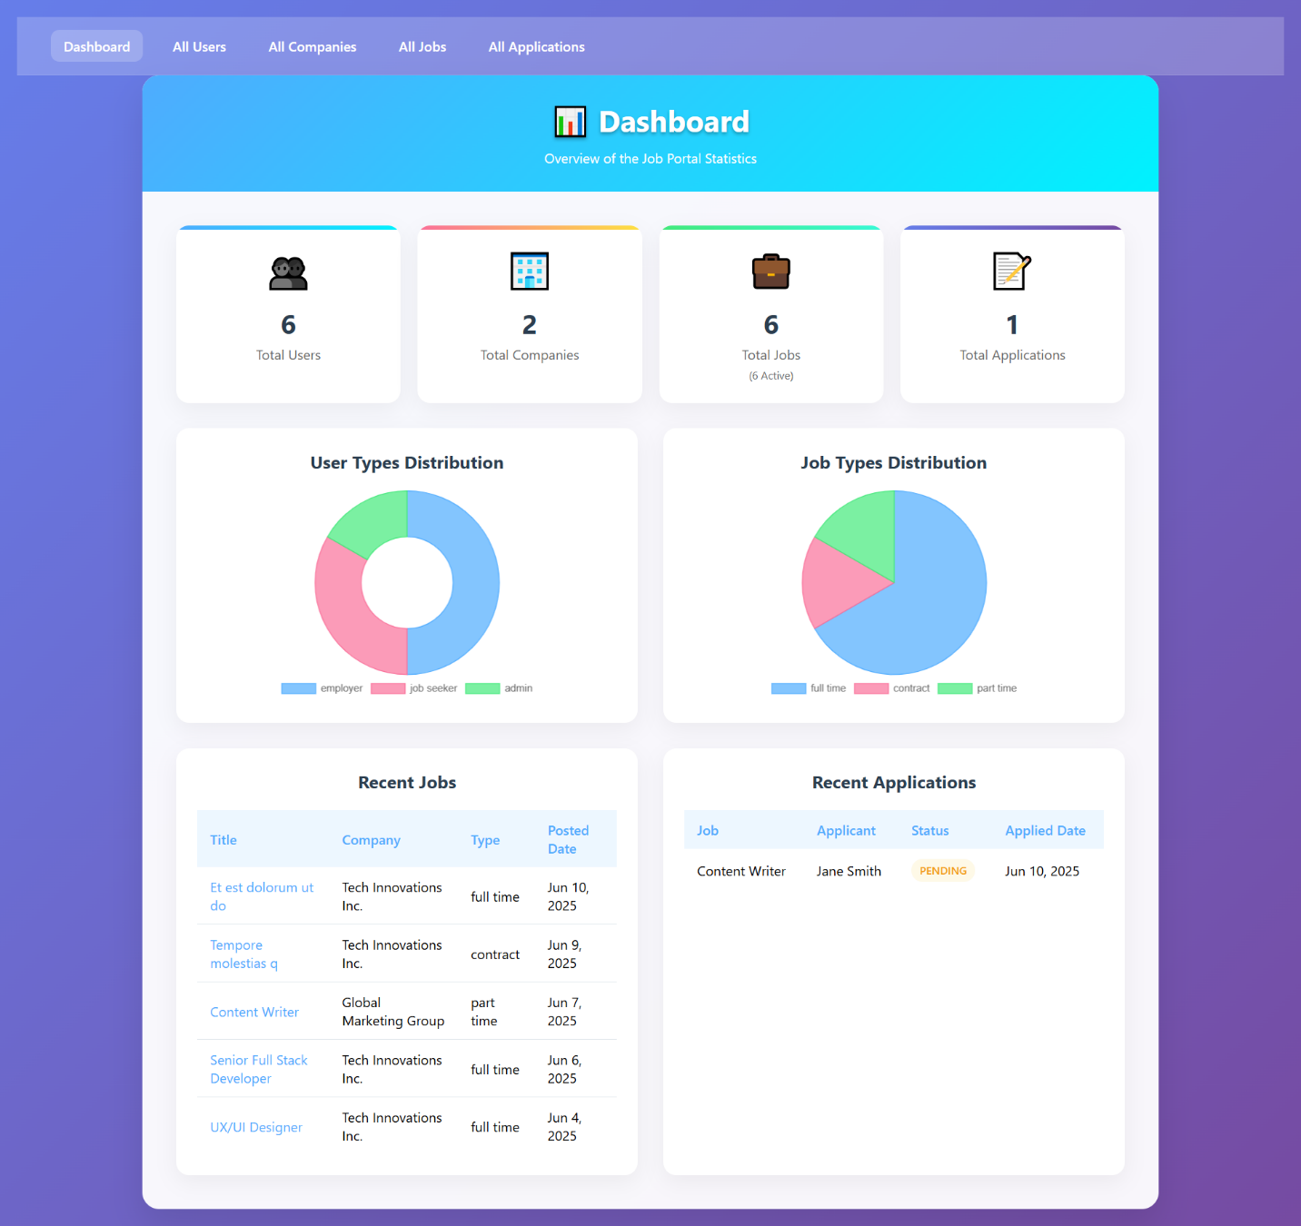

**All Users:**

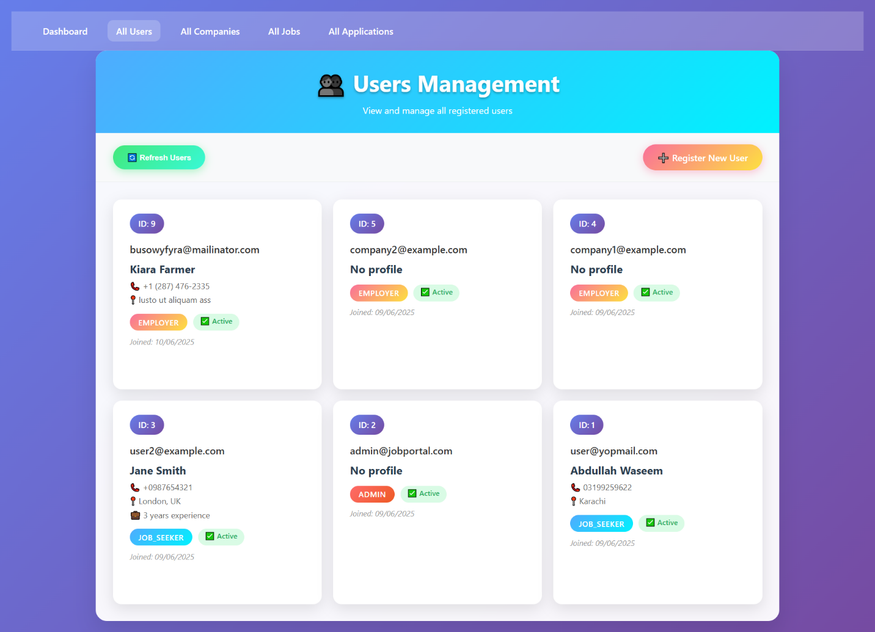

**User Detail Page:**

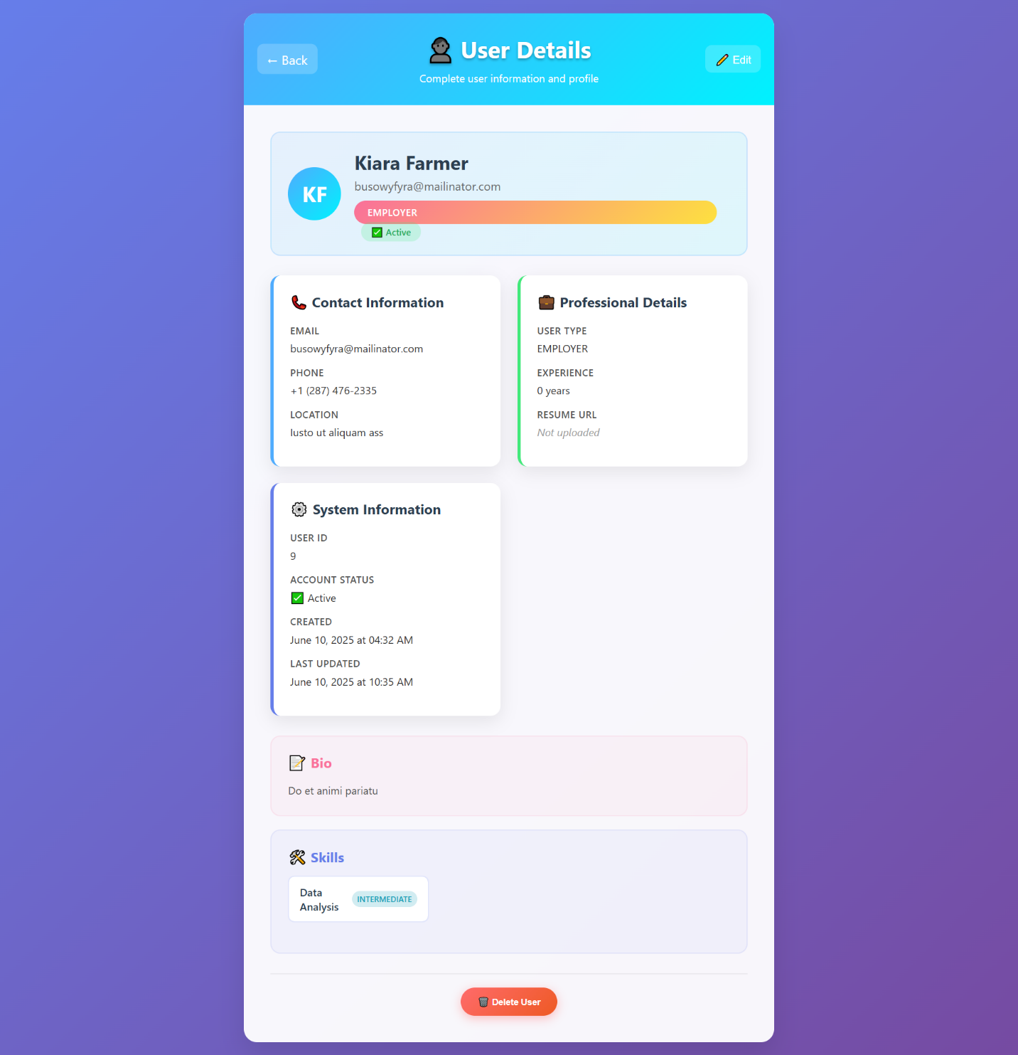

**User Detail Edit Page:**

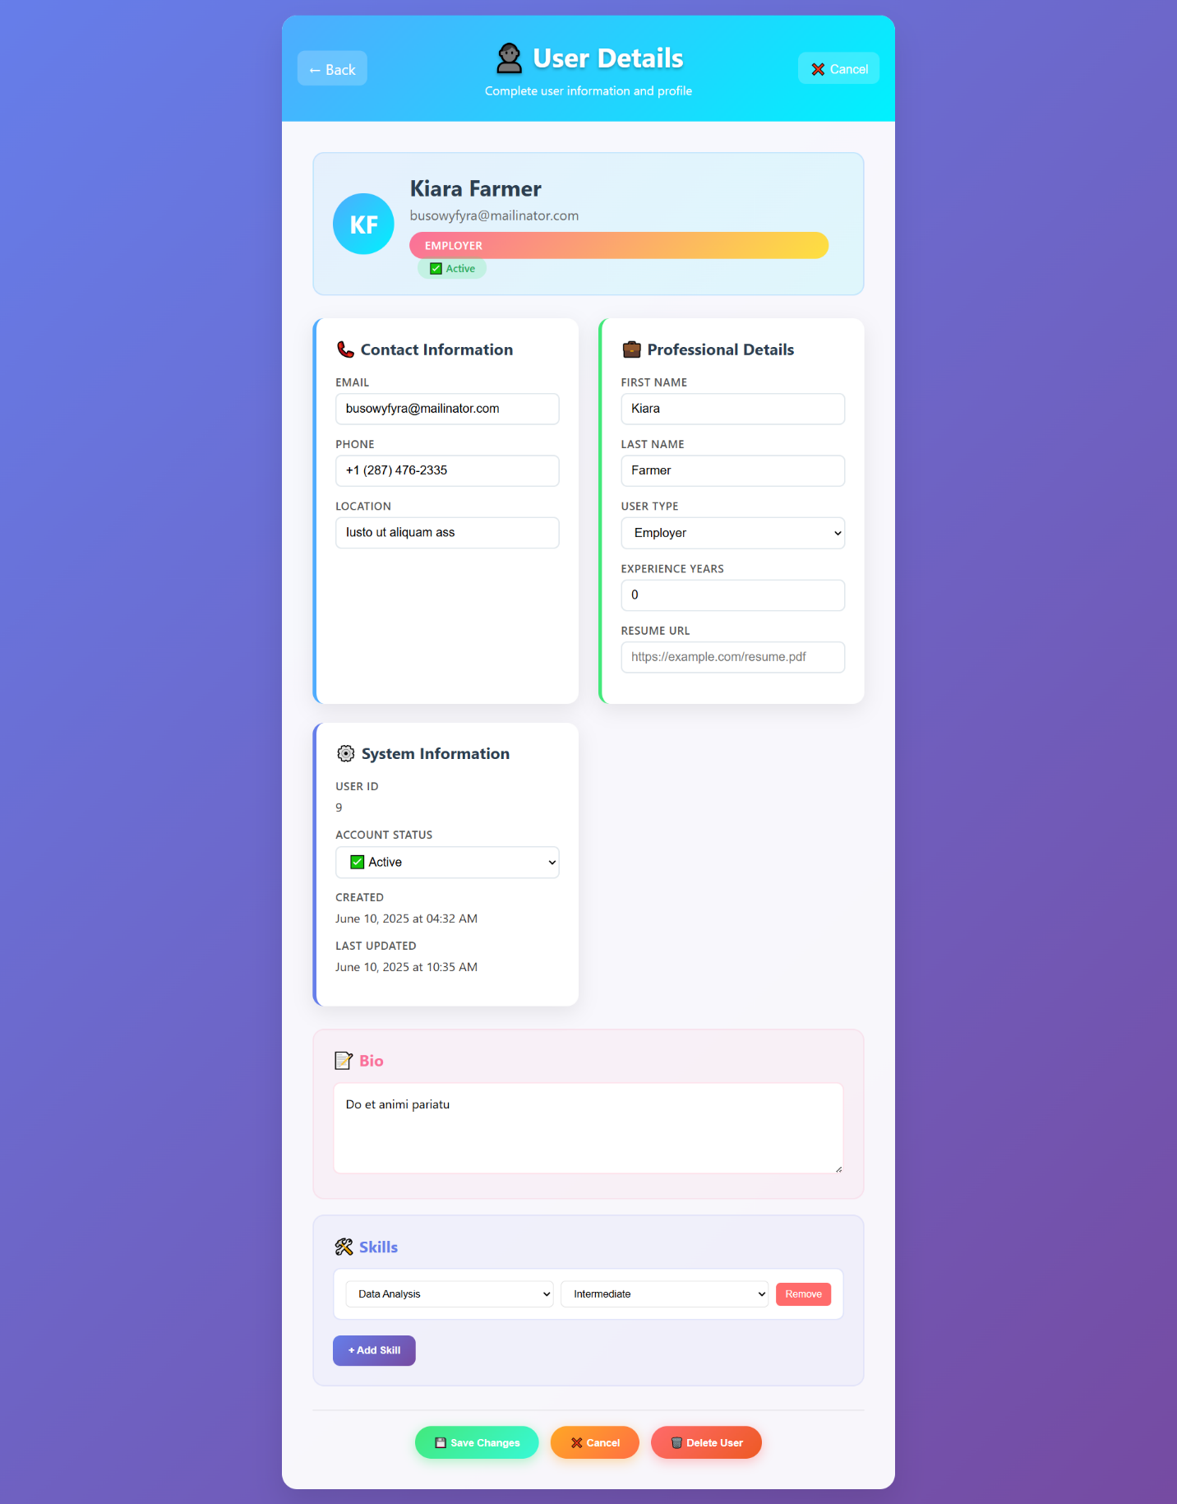

**Register User:**

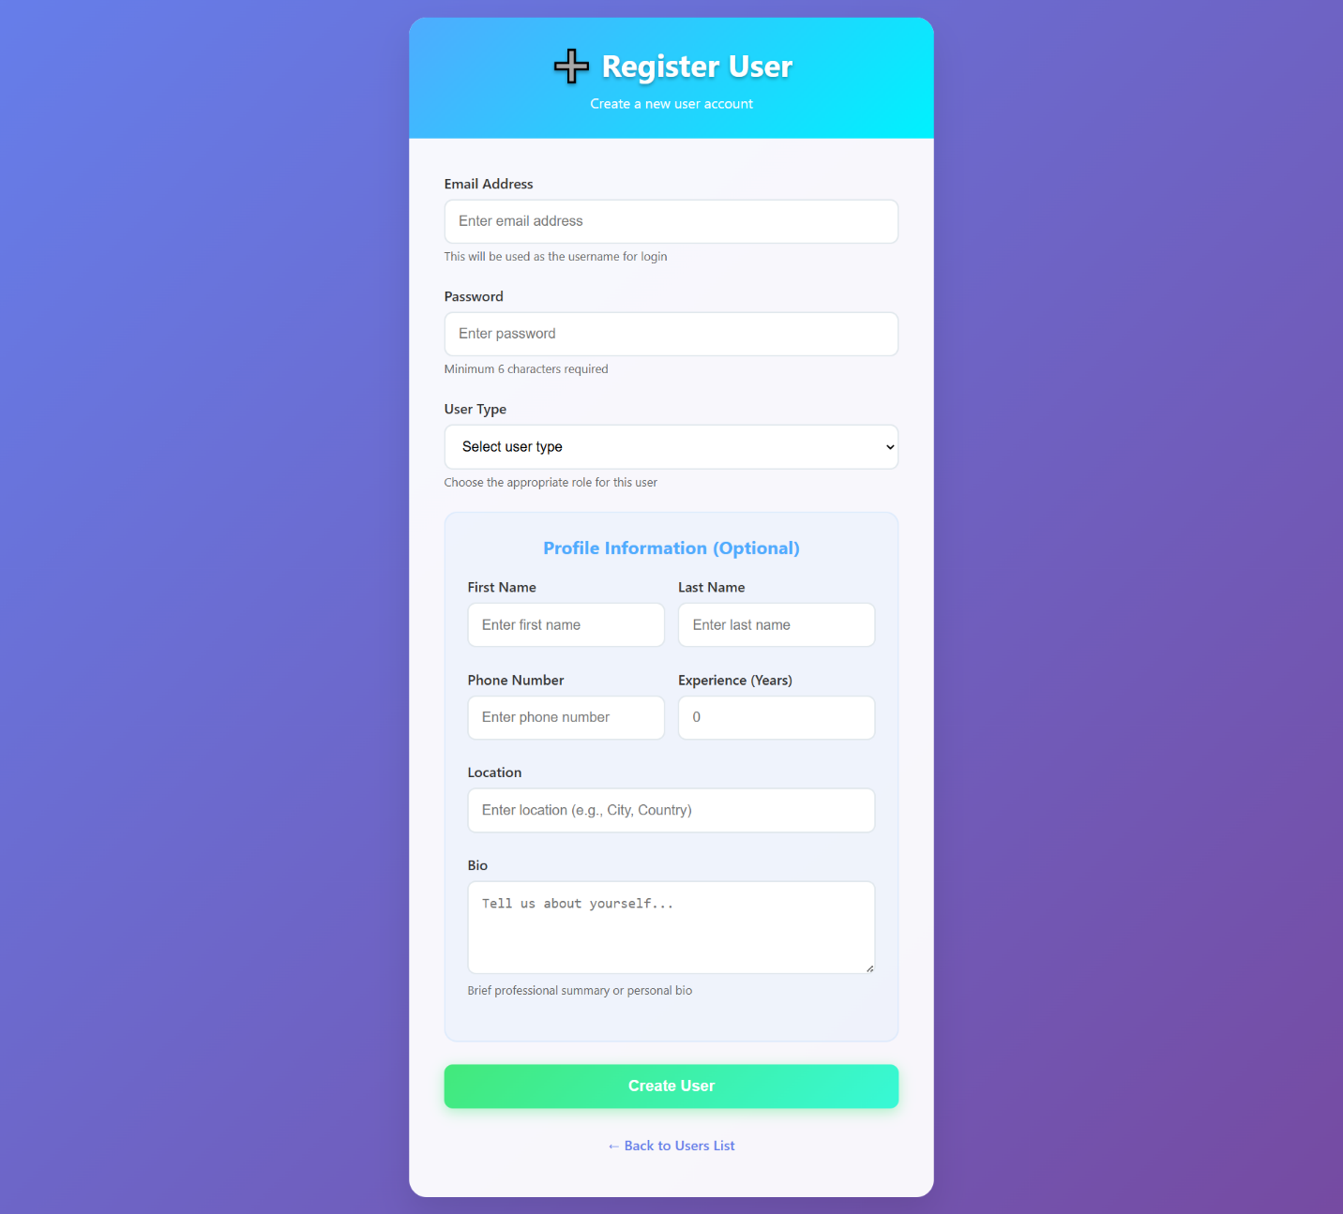

**Register Company:**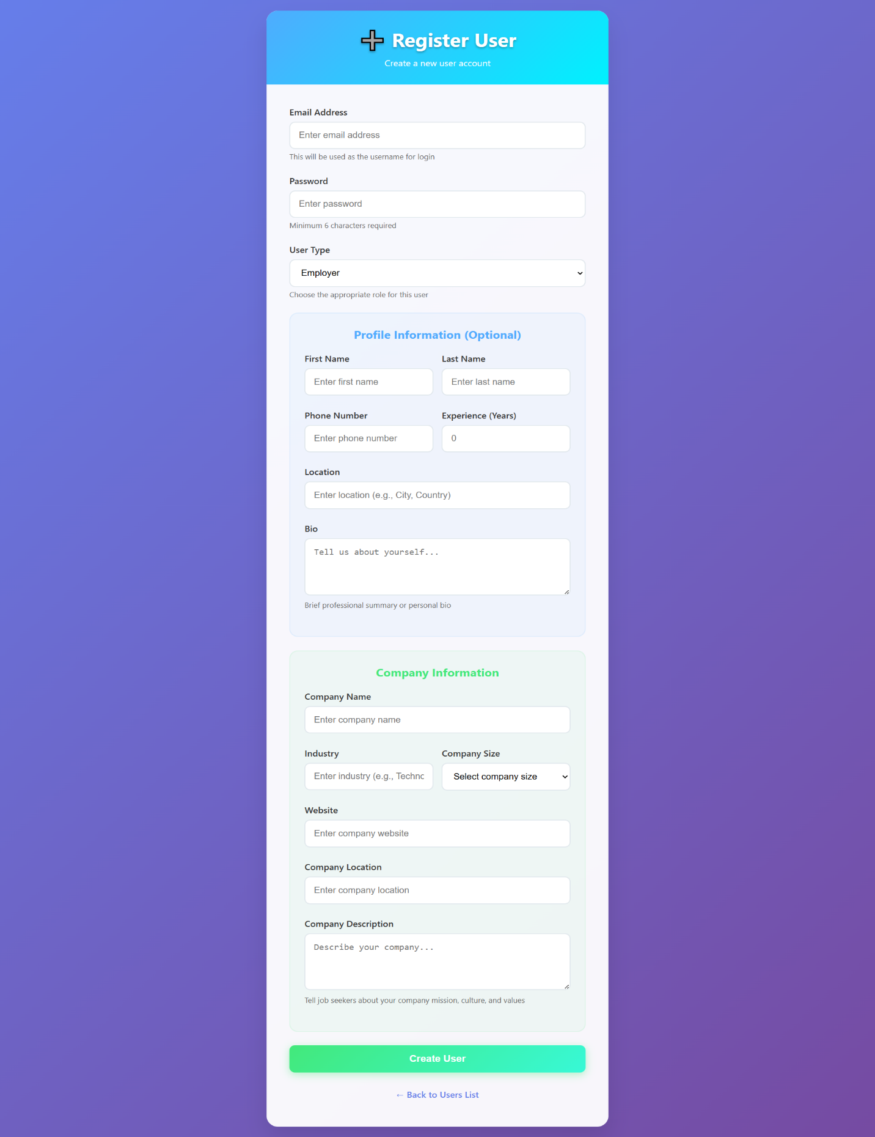

**All Companies**

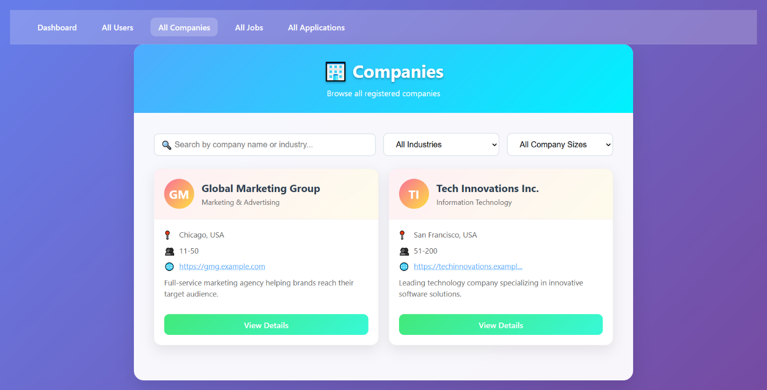

**Company Details and Review Section:**

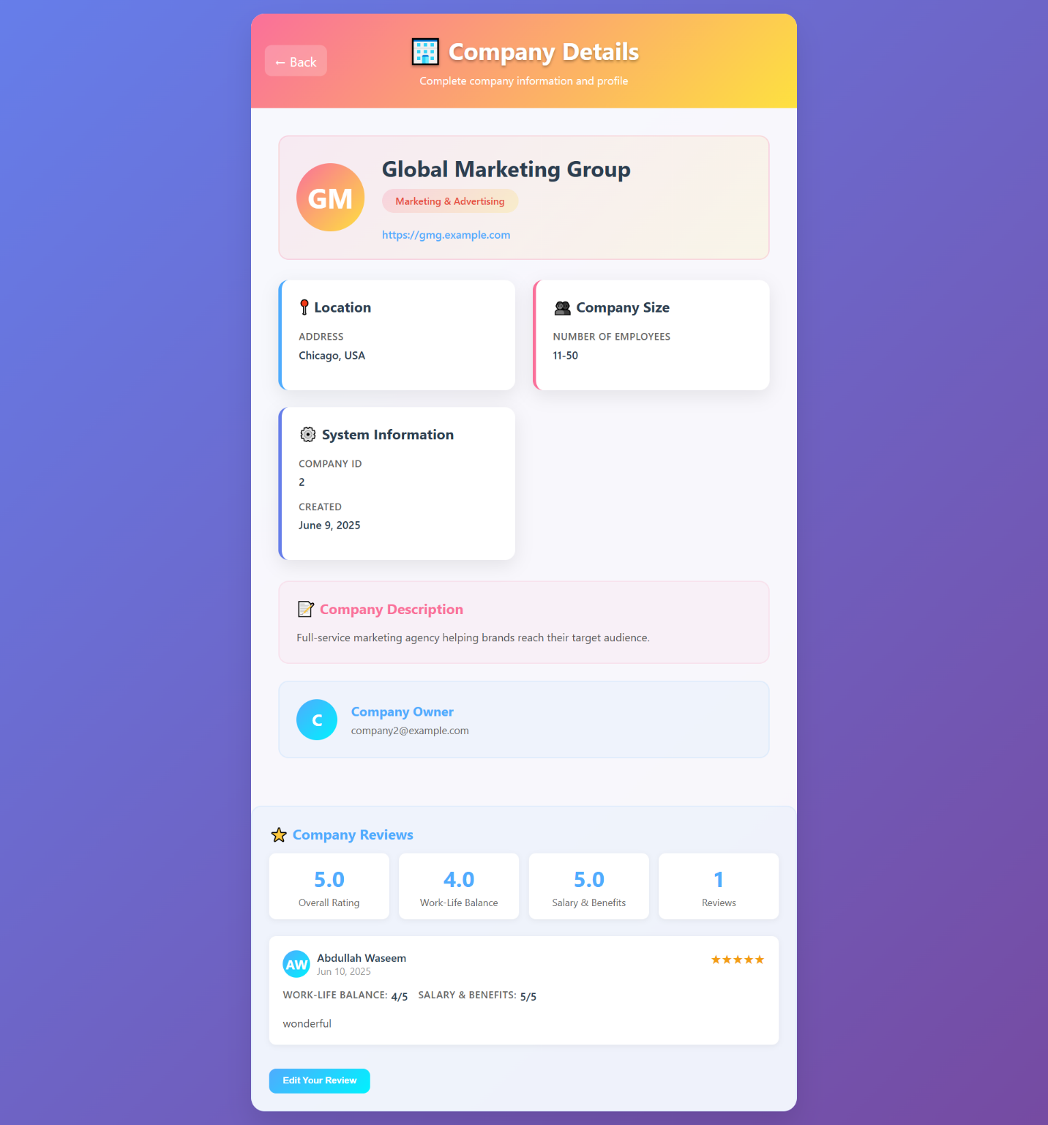

**Edit Review:**

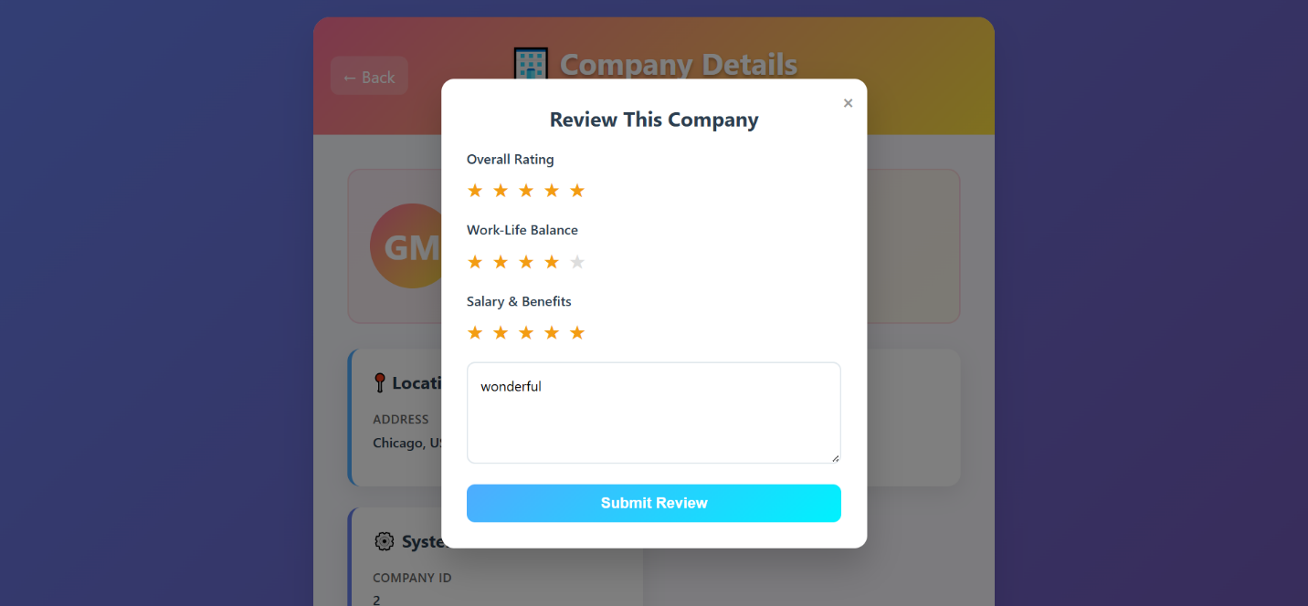

**All Jobs:**

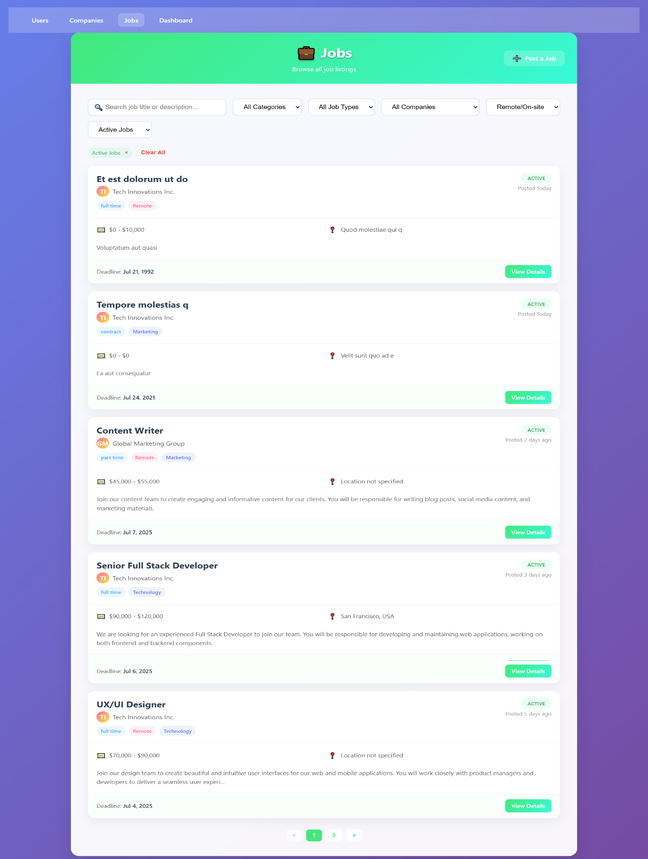

**Job Details:**

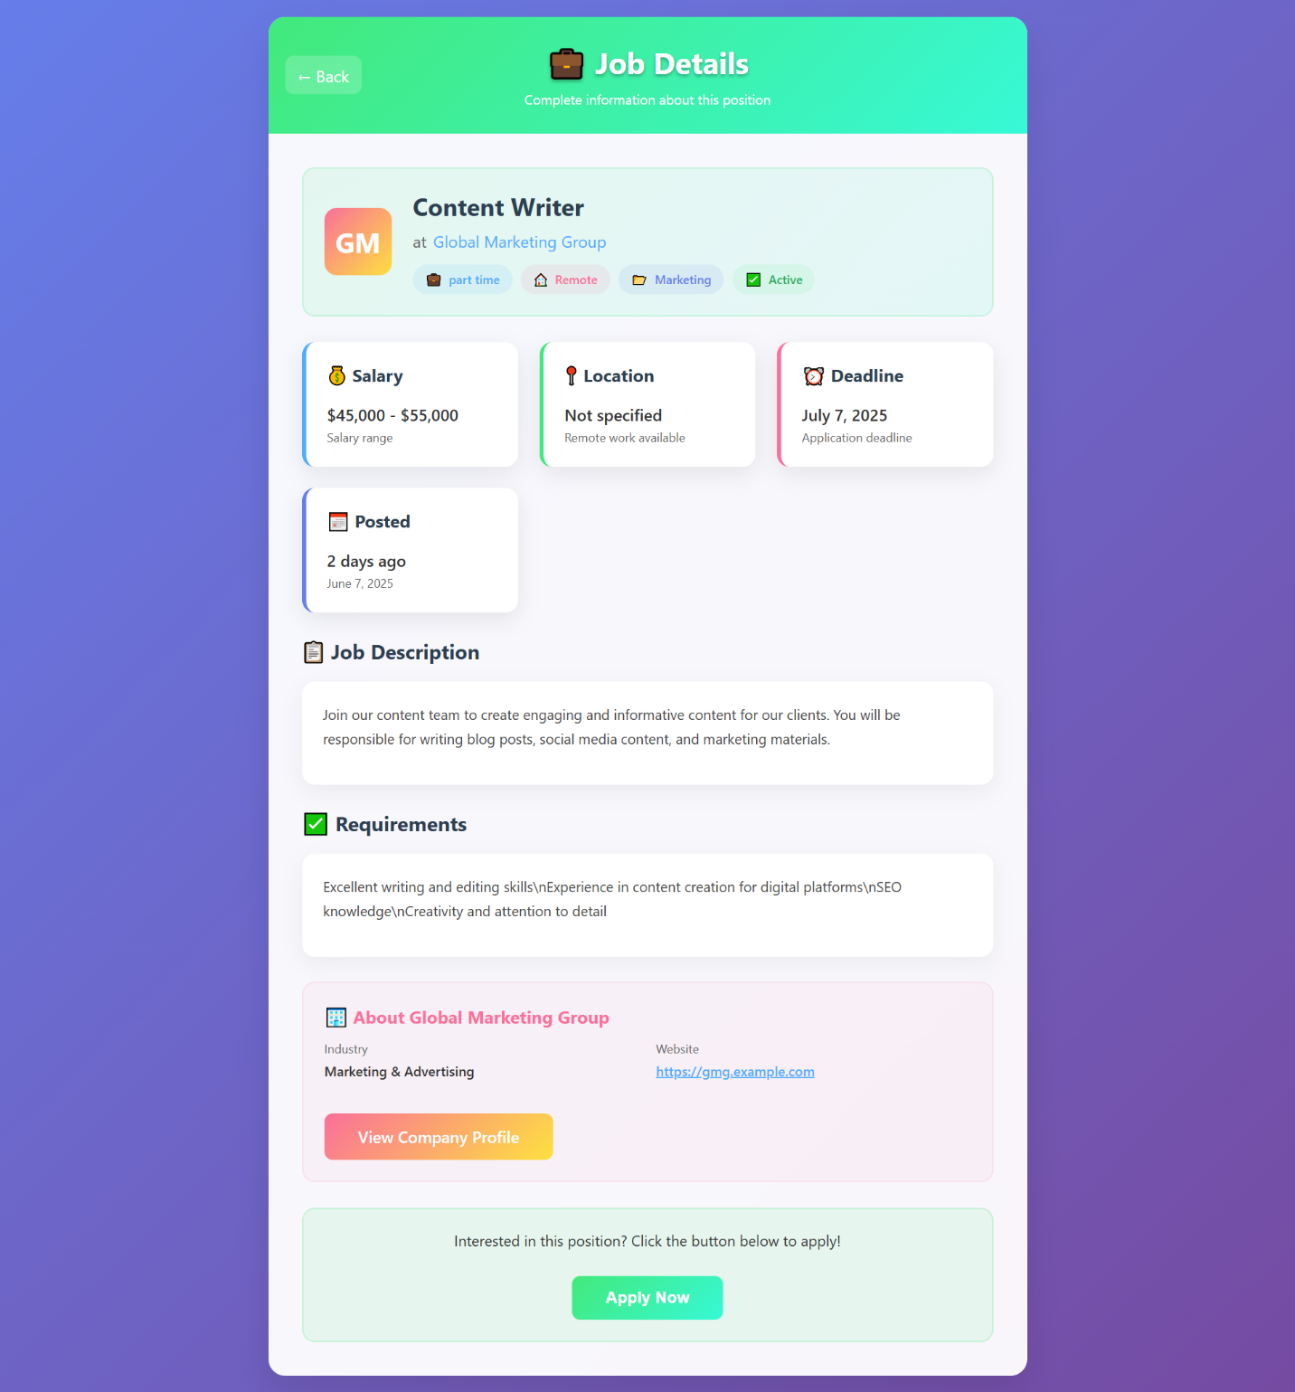

**Apply For Job:**

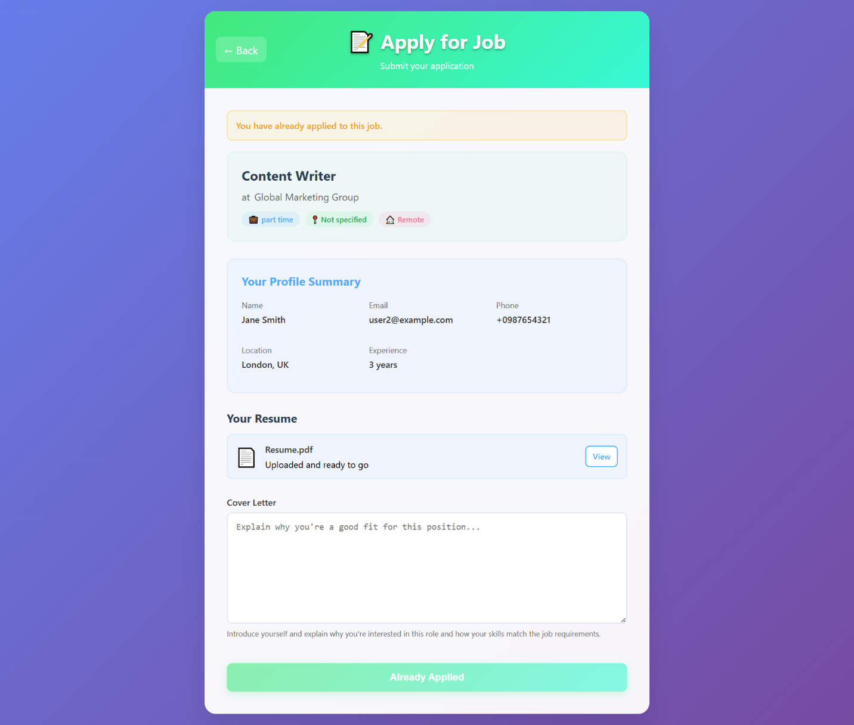

**All Applications:**

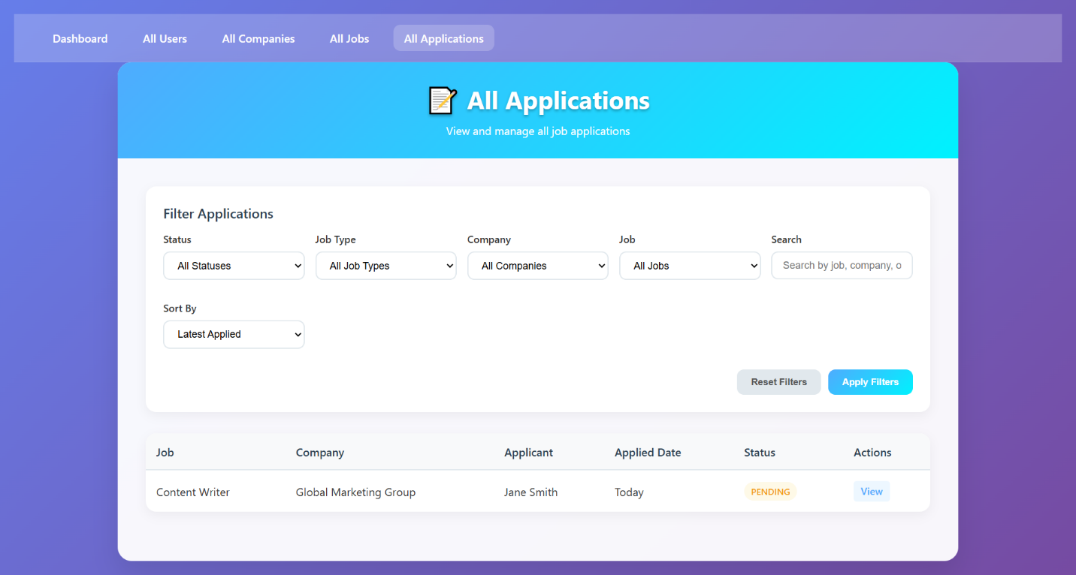

**Single Application:**

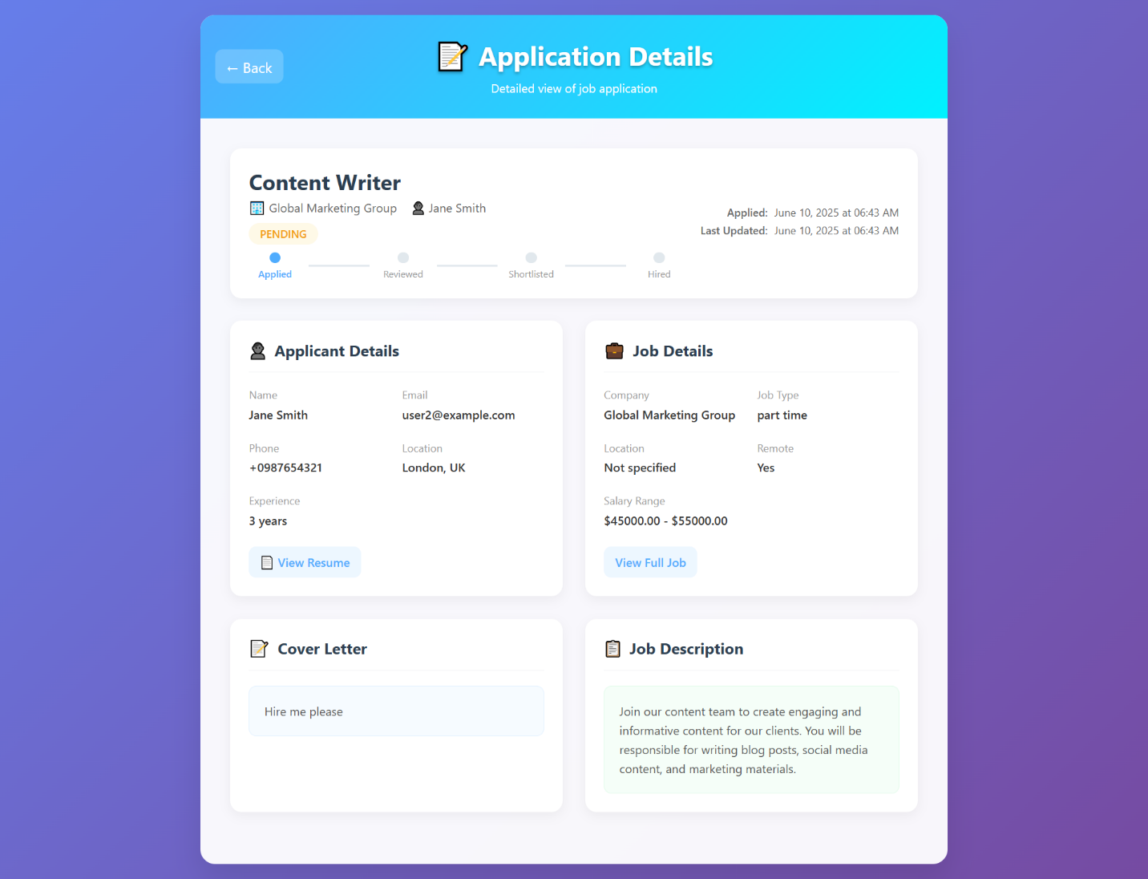

**My Application:**

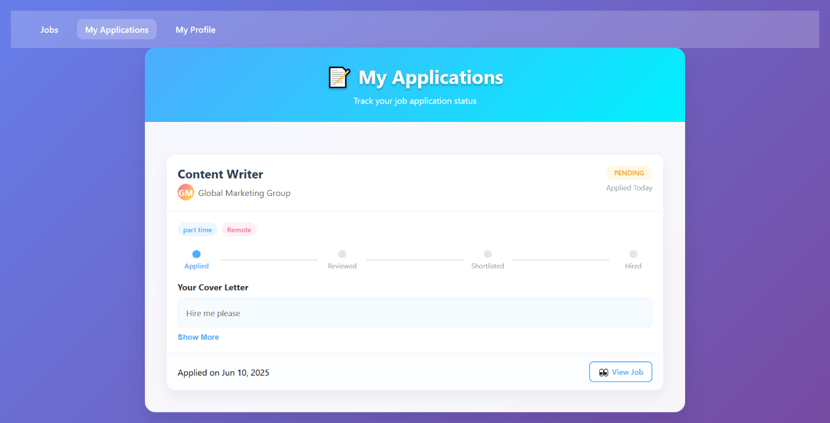

***ERD***

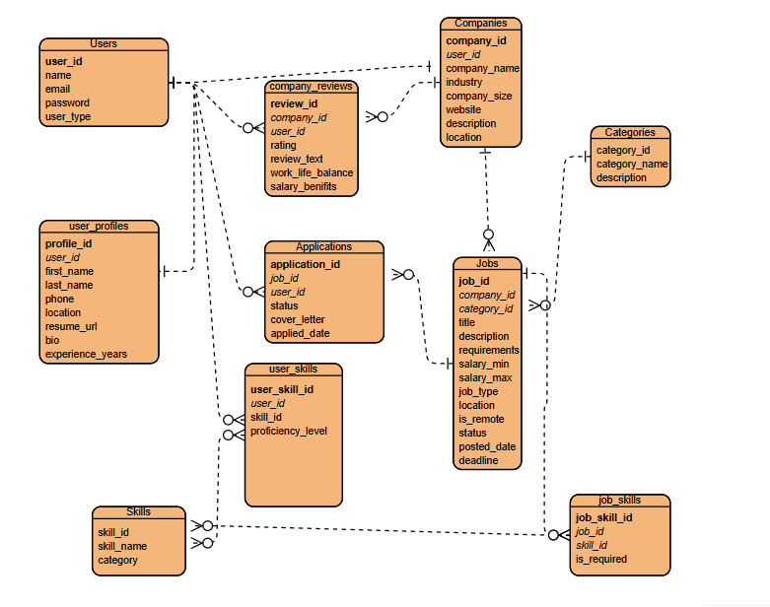

**Thank You**